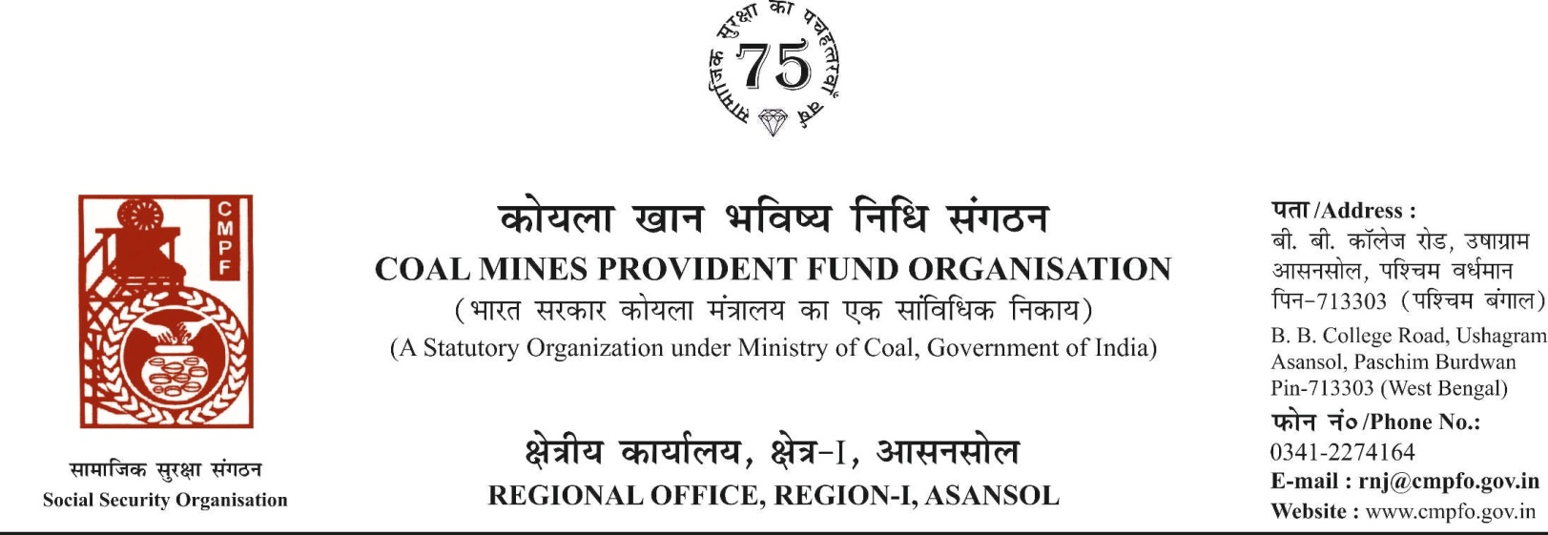

CPF/118/MISC/Extract/Voll-2/R-I/ASN Date-12/08/2025
To,
The Regional Commissioner
Coal Mines Provident Fund ,
R.O- Talcher
AT:- Jagannath colony
P.O & P.S:- South Balanda
Dist:- Angul , State:- Odisha
Pin:- 759116

Sub- Sub- Inter-Regional Extract In-Out
Ref. : CPF/Extract incoming/TLHR-25/Misc/Tal/1783 Dated. : 06/02/2025
Sir,
In view of the revised procedure prescribed in procedure office order No-230 Dated-12/02/1973 of CMPF Commissioner, Dhanbad, I am to state that the ledger card of the following member is forwarded to your office as he is working under jurisdiction of your region.
It is ensured that the posting in the ledger card are dully completed for the periods for which the member was contributing in this region.
SL. No | Name of the member | CMPF A/C No | Name of the colly where member worked in this region | Name o the colliery where member working in your region
1 | Sri Mahamood Miya | NGP/19/2724 | Jhanjra Area (RNJ/40) | Hingula Area (TLHR/25), MCL

Encl- As above
Yours faithfully

Assistant Commissioner

